Nicholas Lynch

C2T4 Market Basket Report

Blackwell Industries

**Summary**:

I think acquiring Electronidex would be beneficial because it has products which work well with our existing product list such as iMacs, Apple Earpods, mice, keyboards, and other accessories that we do not currently carry. Based on my Electronidex transaction data analysis, Blackwell would generate more sales revenue by cross-selling products that are offered by both companies. Nonetheless, additional information is needed to determine how this will affect profitability, supply chain responsiveness, brand image, and customer service prior to acquiring Electronidex.

**Observations**:

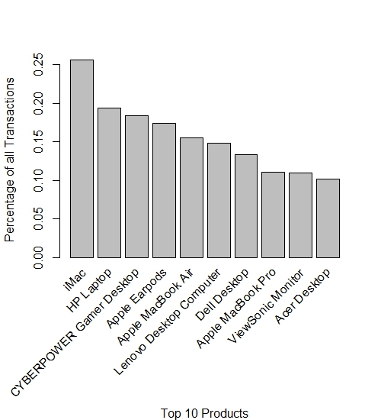

8 of the top 10 products are computers, 5 of which are desktops. Based on my prior report, PCs and laptops are very profitable division for us.

Blackwell carries some of Electronidex’s products, but not the iMac, Cyberpower Desktop, Apple Earpods, and Lenovo Desktops. These new items are in the top 6 selling products for Electronidex.

**Insightful Product Associations**

People are buying laptops/PCs of different brands and operating systems at the same time. You would think people would buy the same brand of laptops/PCs in order to use the same operating system.

The following insights were gained from the market basket analysis: People who bought iMacs bought Lenovo Desktops. Cyberpower Desktops, and other non-Mac items that we already carry. Conversely, people who bought Windows desktops and laptops also bought iMacs. Blackwell would benefit from selling from iMacs, Lenovo desktops, Cyberpower Desktops, and Apple Earpods. iMacs and Cyberpower Desktop are high value products that are usually bought with products we already carry.

**Rules generated from transaction data**

|  |  |  |
| --- | --- | --- |
| **People who buy this** | **Usually buy this** | **Transaction count** |
| ViewSonic Monitor | iMac | 486 |
| Dell Desktop | iMac | 537 |
| Lenovo Desktop Computer | iMac | 578 |
| HP Laptop | iMac | 743 |
| CYBERPOWER Gamer Desktop | iMac | 558 |
| iMac | Dell Desktop | 537 |
| iMac | Lenovo Desktop Computer | 578 |
| iMac | HP Laptop | 743 |
| iMac | CYBERPOWER Gamer Desktop | 558 |

**Future Business Steps**

If Electronidex is acquired, I recommend the following:

* Cross-selling iMacs with windows desktops/laptops(and vice versa)
* A sales promotion Electronidex/Blackwell legacy customers give e-mail discounts on new products that each retailer did not previously carry. This will increase cross-selling.
* Carry all products on both websites.